**Name: Laxmi Shejwal Roll no.: 17**

**Class: MSc CS Part I Subject: DWDM Academic Year: 2021-2022**

**Practical 1**

**Aim:** Perform analysis on AdventureWorks dataset using Microsoft Excel and Visual Studio 2019.

Procedure:

* Open Visual Studio 2019. You should be greeted with this screen.

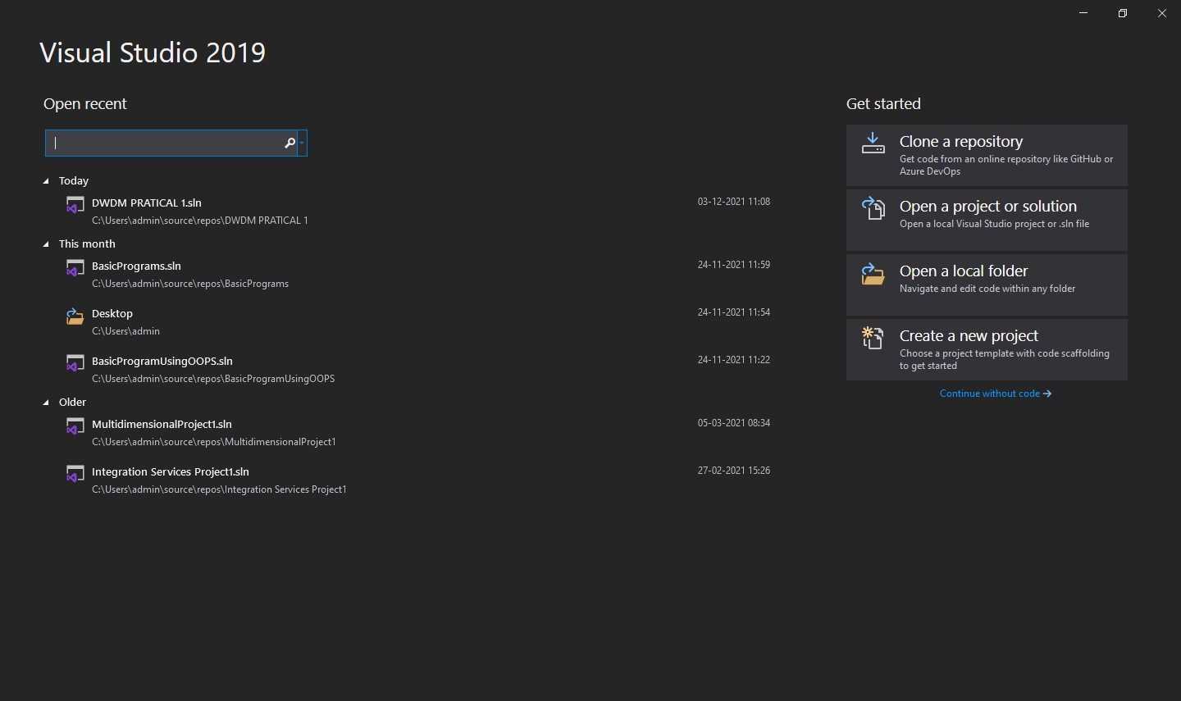

* Click on the “Create a new project” button present on the right hand side of the screen. The application will now transition to this screen.

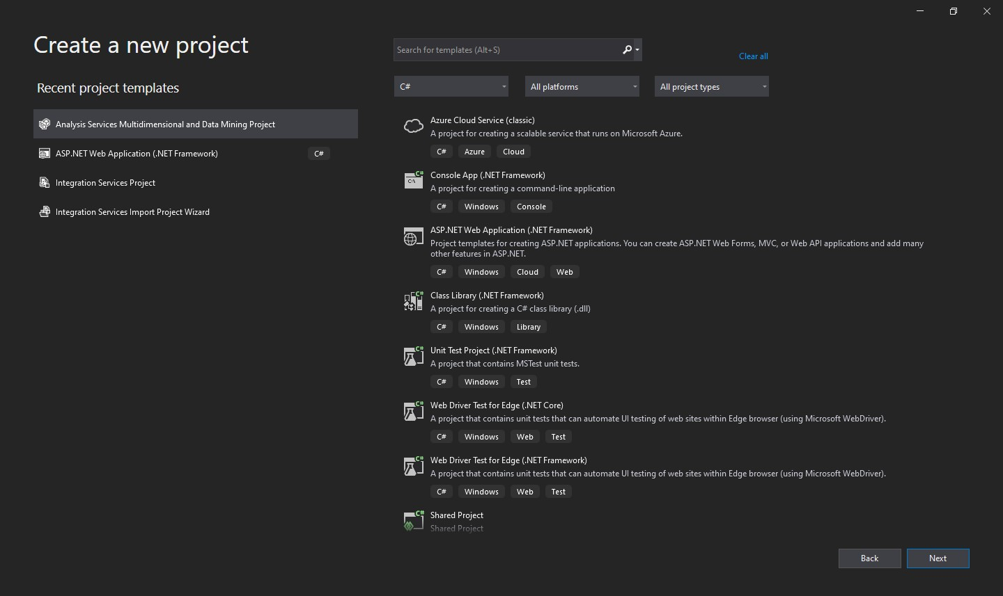

* Now, select “Analysis Services Multidimensional and Data Mining Project” button from the ‘Recent Project Templates’ list if present else search for the same using the search bar. You may be prompted to install this package if it is not available locally. Searching for the above template yields this screen:

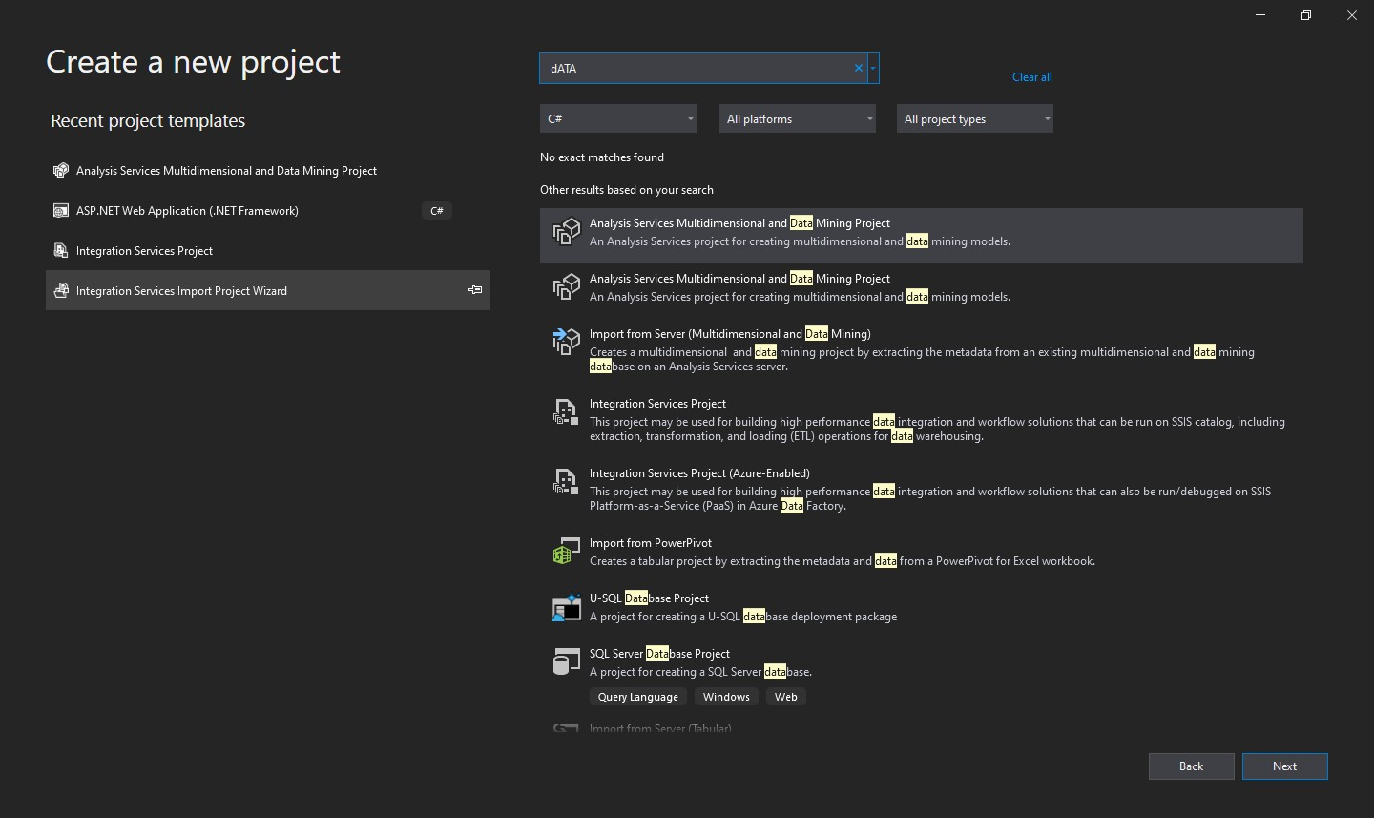

* Click on “Next”. The screen will now transition to this screen:

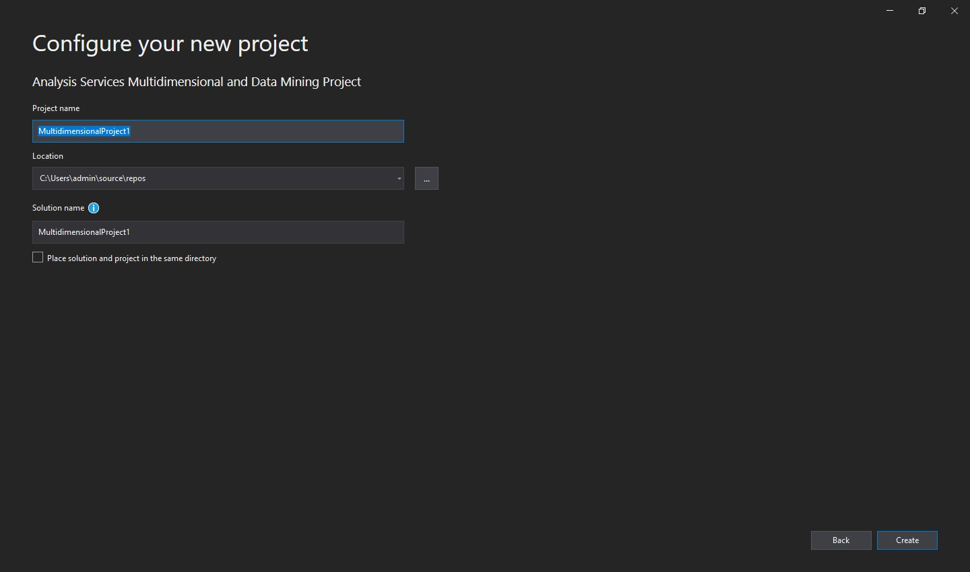

* You can provide the location of the project as well its name.

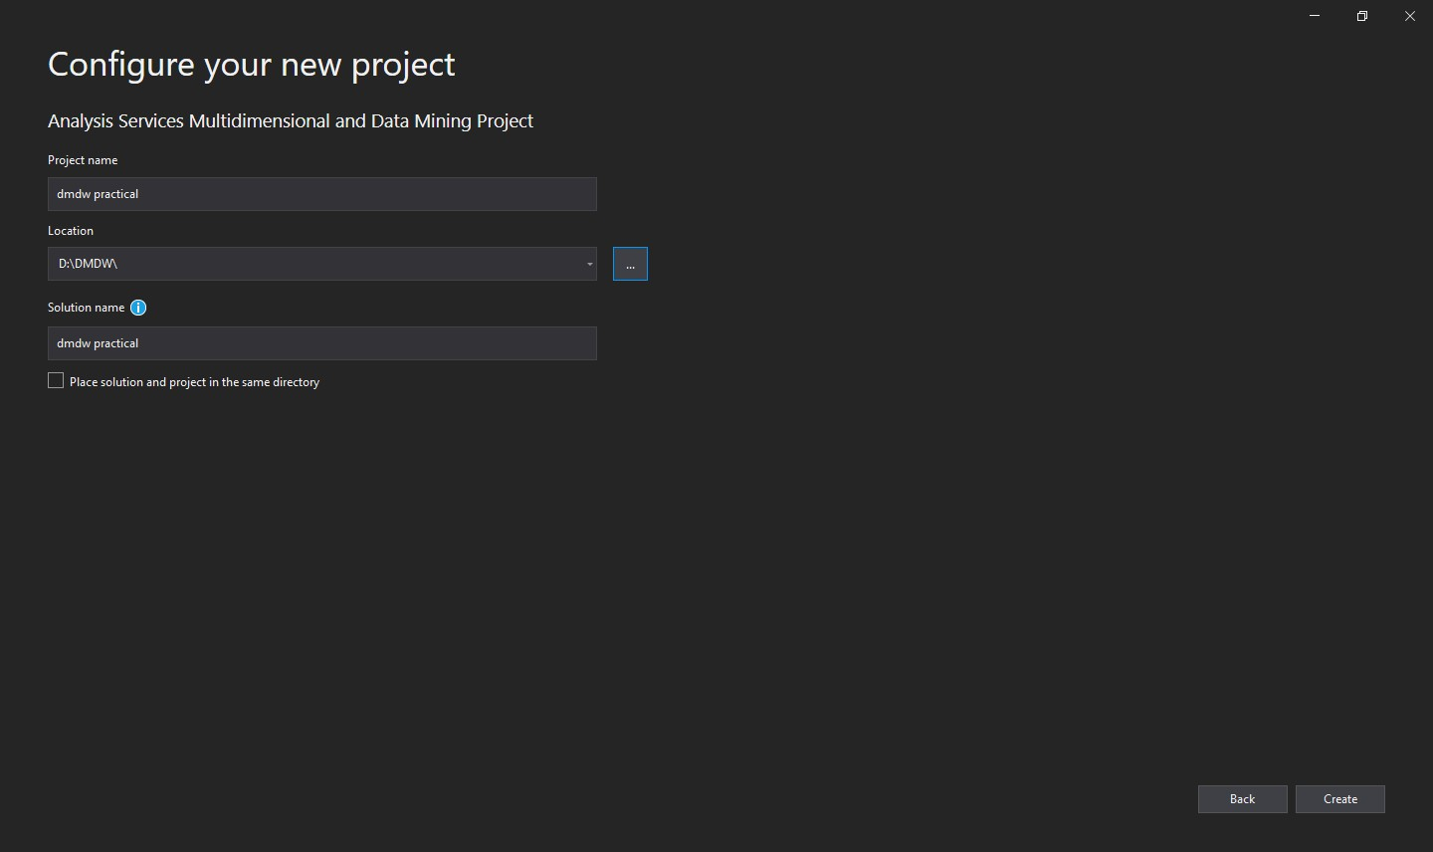

* Click on “Create”. The main window of Visual Studio will be displayed. Now, on the right pane, the child node ‘Data Sources’ can be found. Right click it to get the option “New Data Source”.

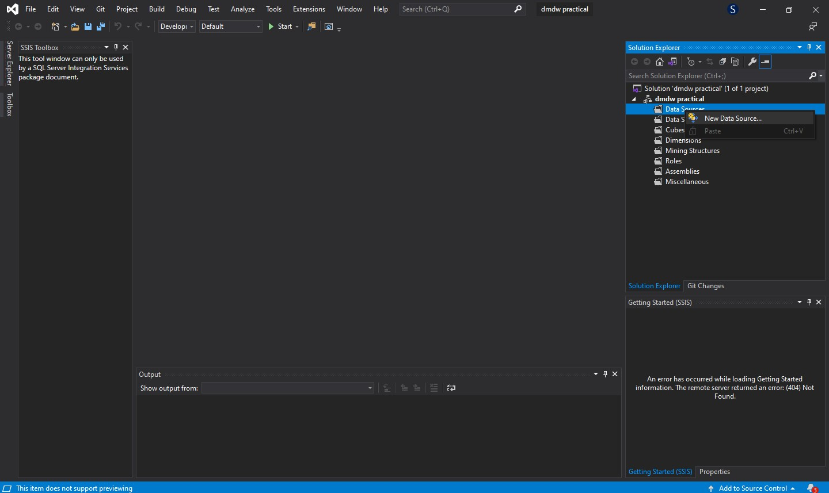

* Click on “New Data Source” option. A new window named ‘Data Source Wizard’ will appear. Click on “Next”. Now, the window should transition to the ‘Select how to define the connection’ window. Select the “Create a data source based on new or existing connection”. An entry should now appear in the ‘Data Connections’ and ‘Data Connection Properties’. Select the appropriate connection.

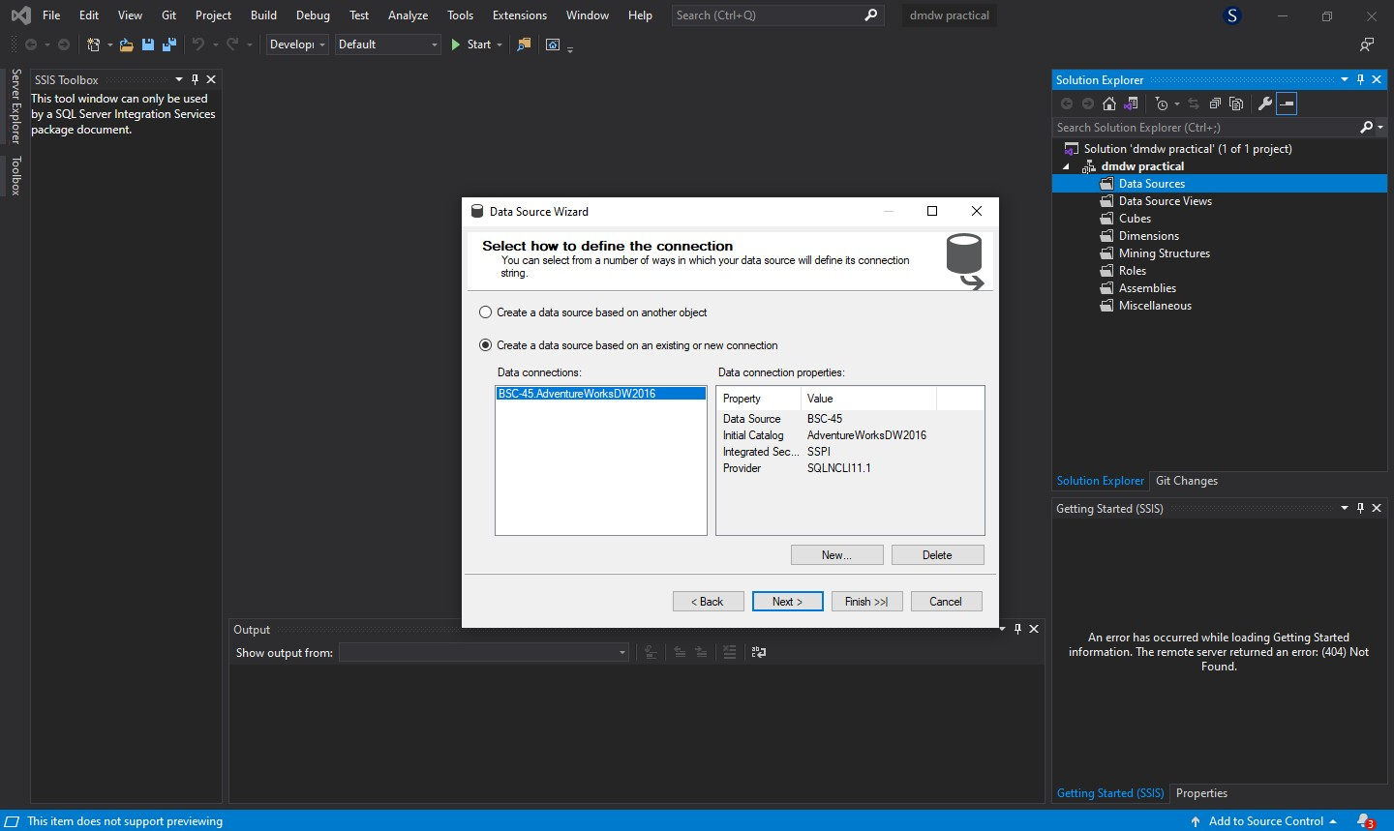

* Click on “Next”. The window will further transition to the ‘Impersonation Information’ window. Select the “Inherit” option.

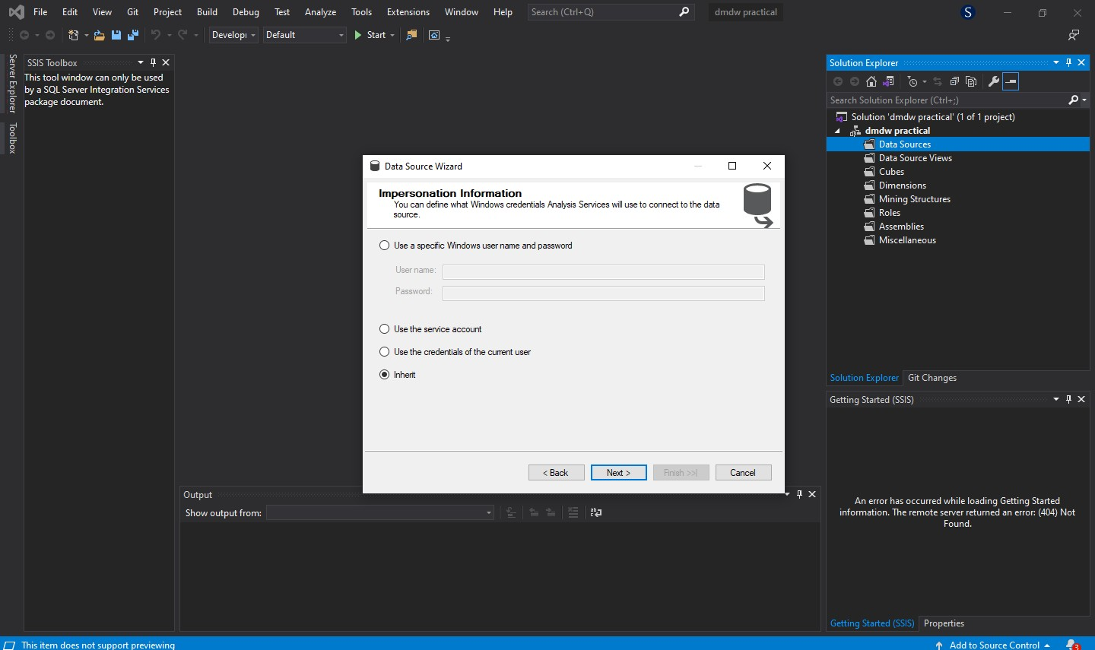

* Click on “Next”. The window will now transition to the last window. Click on “Finish”. The window will now close to reveal a child element in the ‘Data Sources’ tree item. Right click on the ‘Data

Source Views’ tree item present directly below the ‘Data Sources’ parent node to generate a popup menu with the “New Data Source View” menu item.

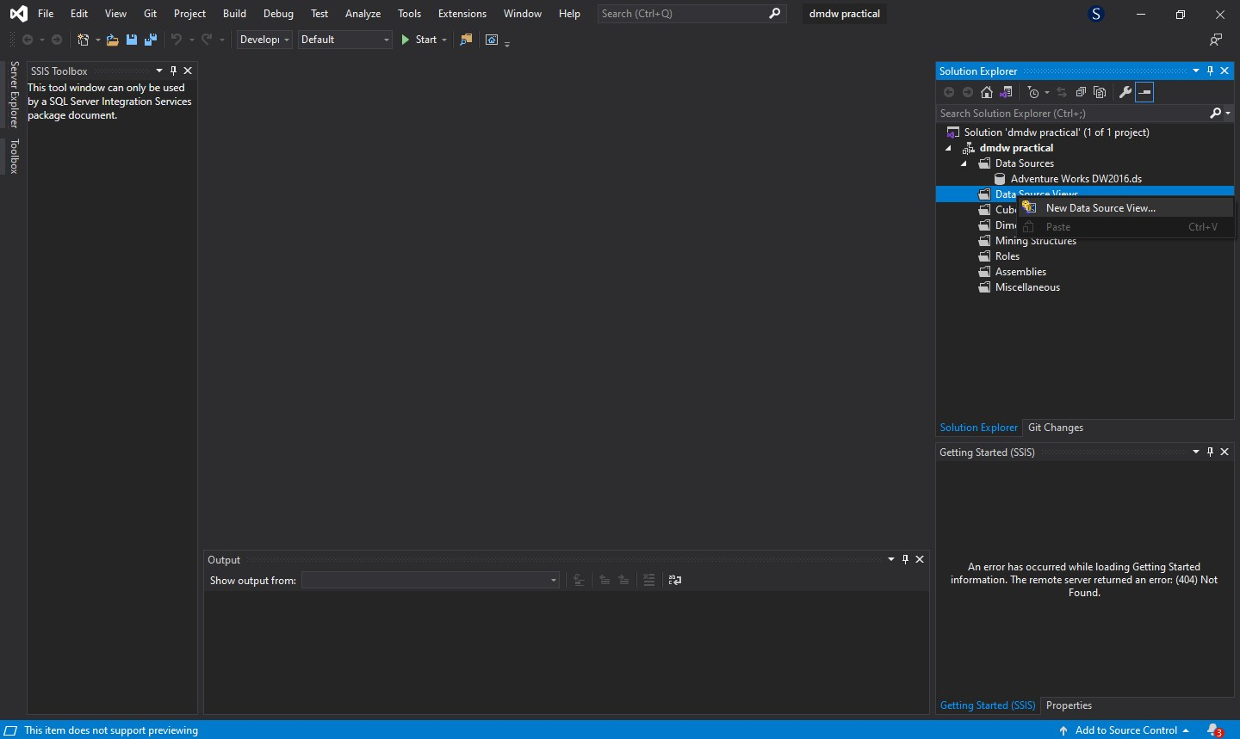

* Click “New Data Source View” to create a new window titled ‘Data Source View Wizard’. Click on “Next” to transition the window to ‘Select Tables and Views’ state. Enter a filter of your choice and press the adjoining button to apply the filter.

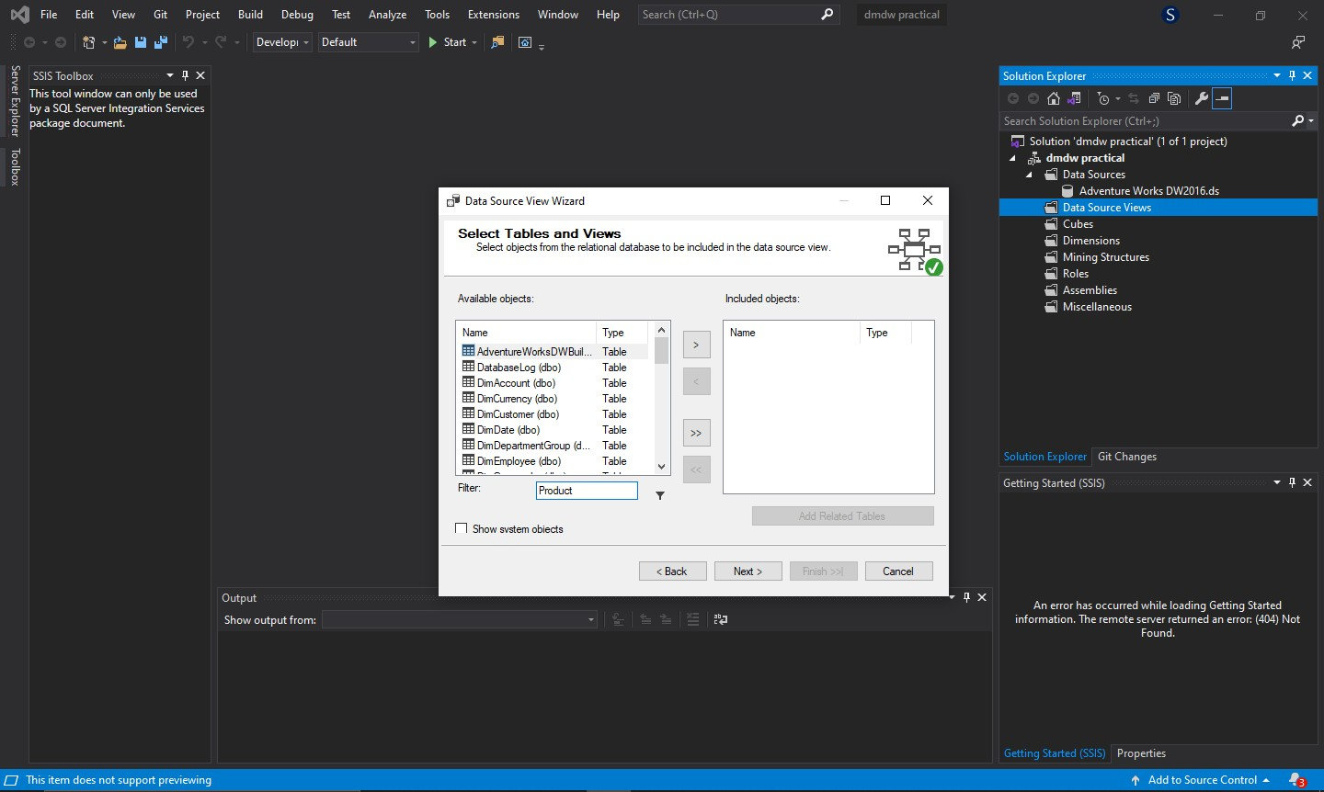

* Now, click on the “>>” button to select all the filtered entries from the ‘Available Objects’ into the ‘Included Objects’ list.

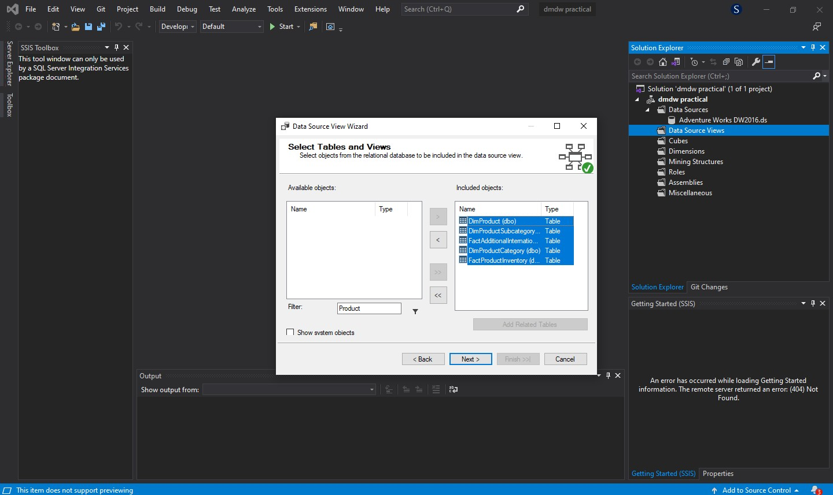

* Click on “Next”. The window will further transition to a new state. Click on “Finish” to close the window. The window will now close to reveal a child node in the ‘Data Source Views’ tree item. Right

click on the ‘Cubes tree item present directly below the ‘Data Source Views’ parent node to generate a popup menu with the “New Cube” menu item.

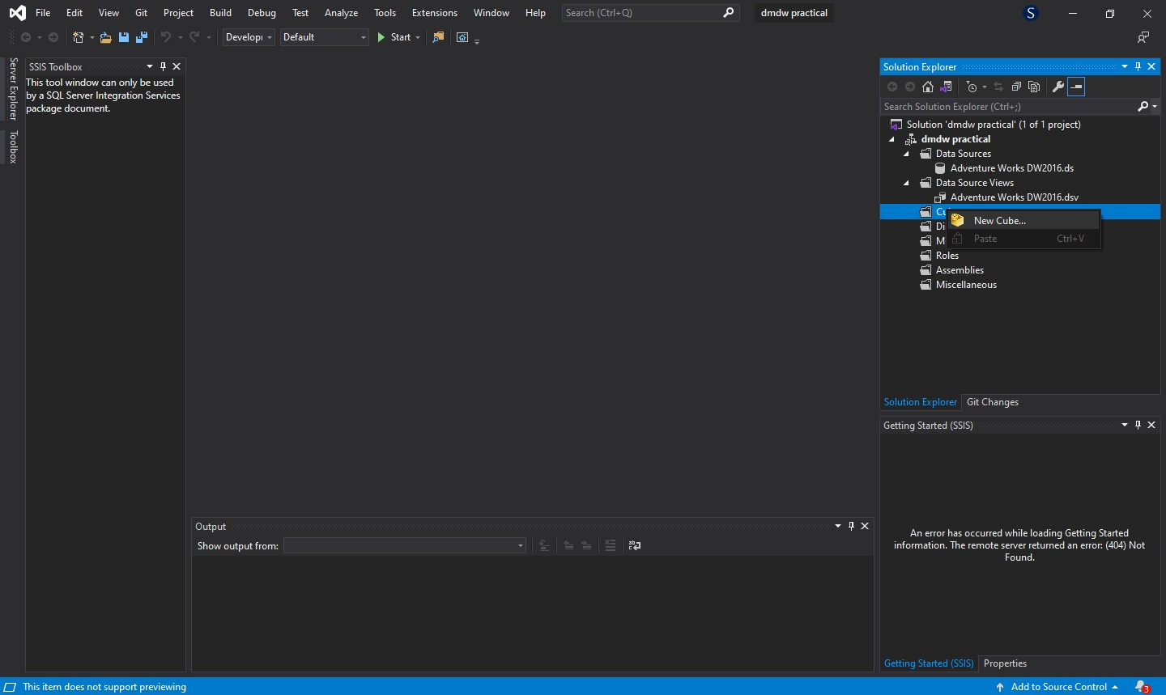

* Click “New Cube...” to create a new window titled ‘Cube Wizard’. Click on “Next” to transition the window to ‘Select Creation Method’ state. Select the “Use existing tables” option.

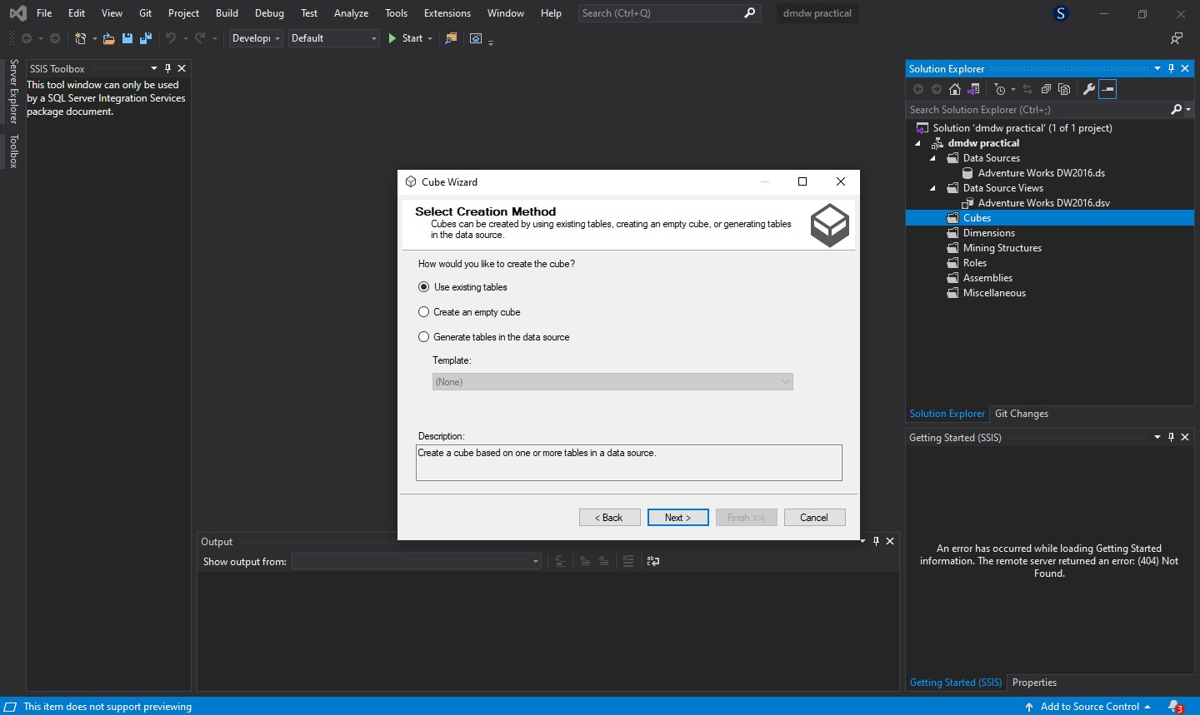

* Click on “Next”.The window will now transition to the ‘Select Measure Group Tables’ state. Select the tables from the ‘Measure Group Tables’ list.

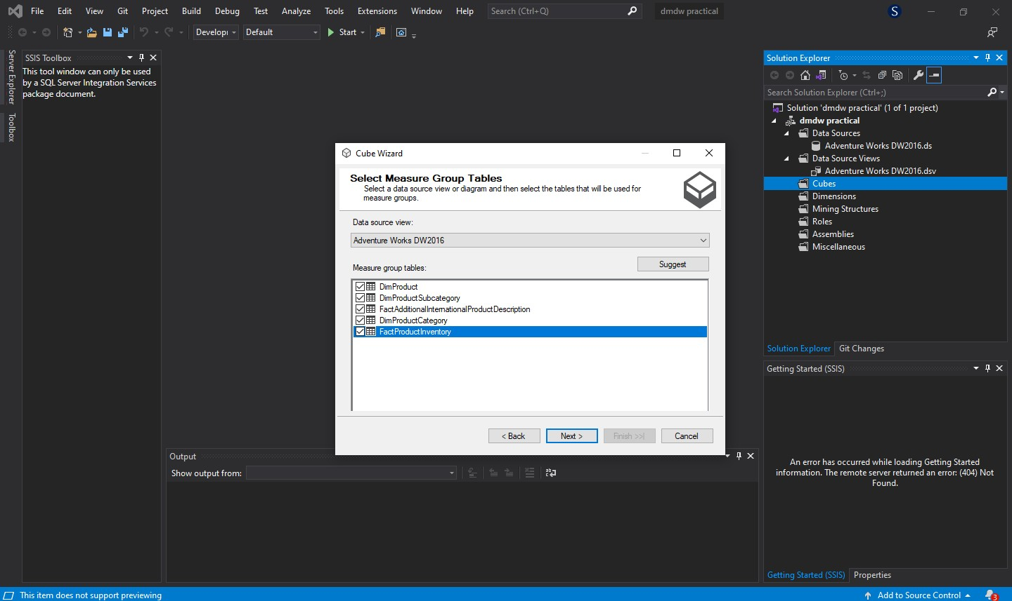

* Click on “Next”. The window will now transition to its final state named ‘Completing the Wizard’. Check the ‘Preview’ section and if everything is okay, click on “Finish”.

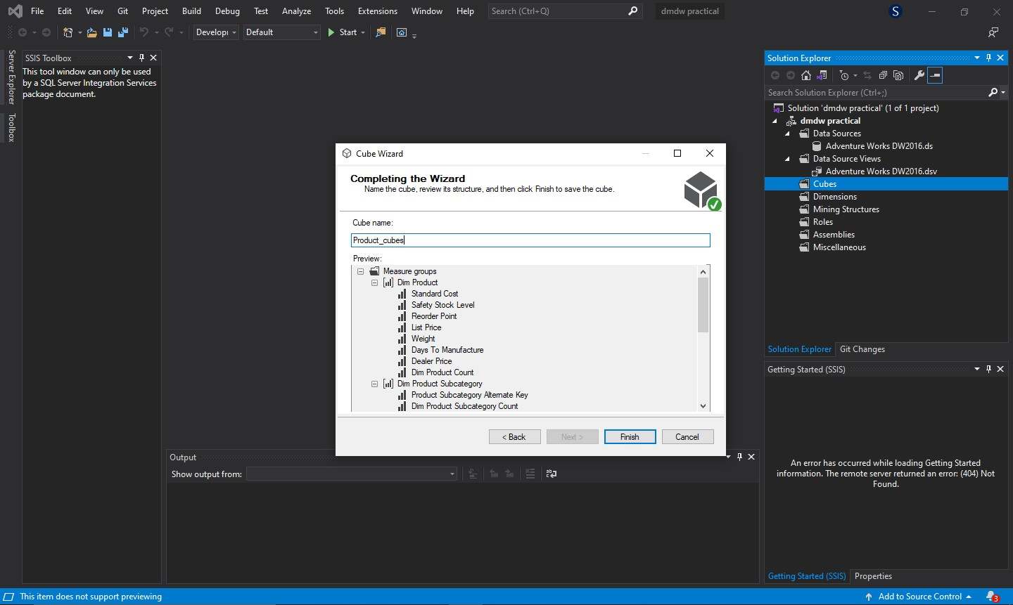

* A diagram should now appear on the screen displaying the logical star schema of the selected tables.

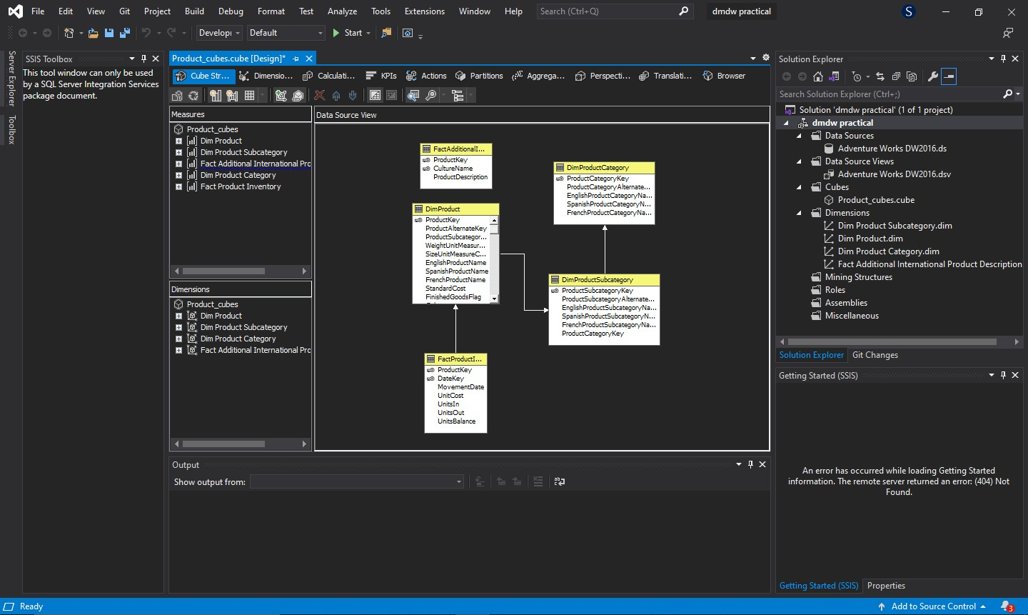

* Now right click the generated cube to reveal a popup menu.

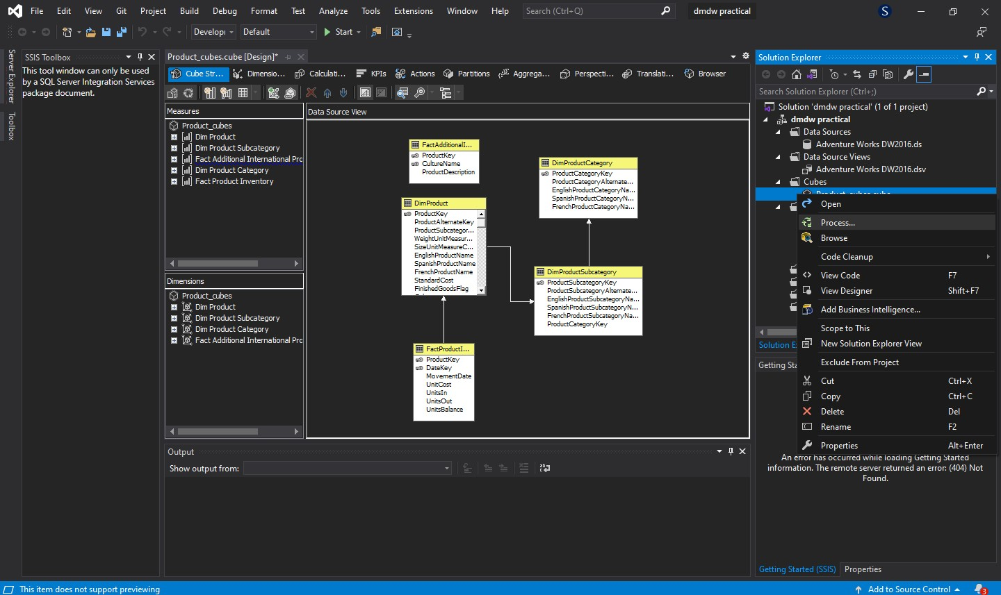

* Click on the “Process...” menu item to generate the ‘Process Cube –

{Cube_Name}’ window.

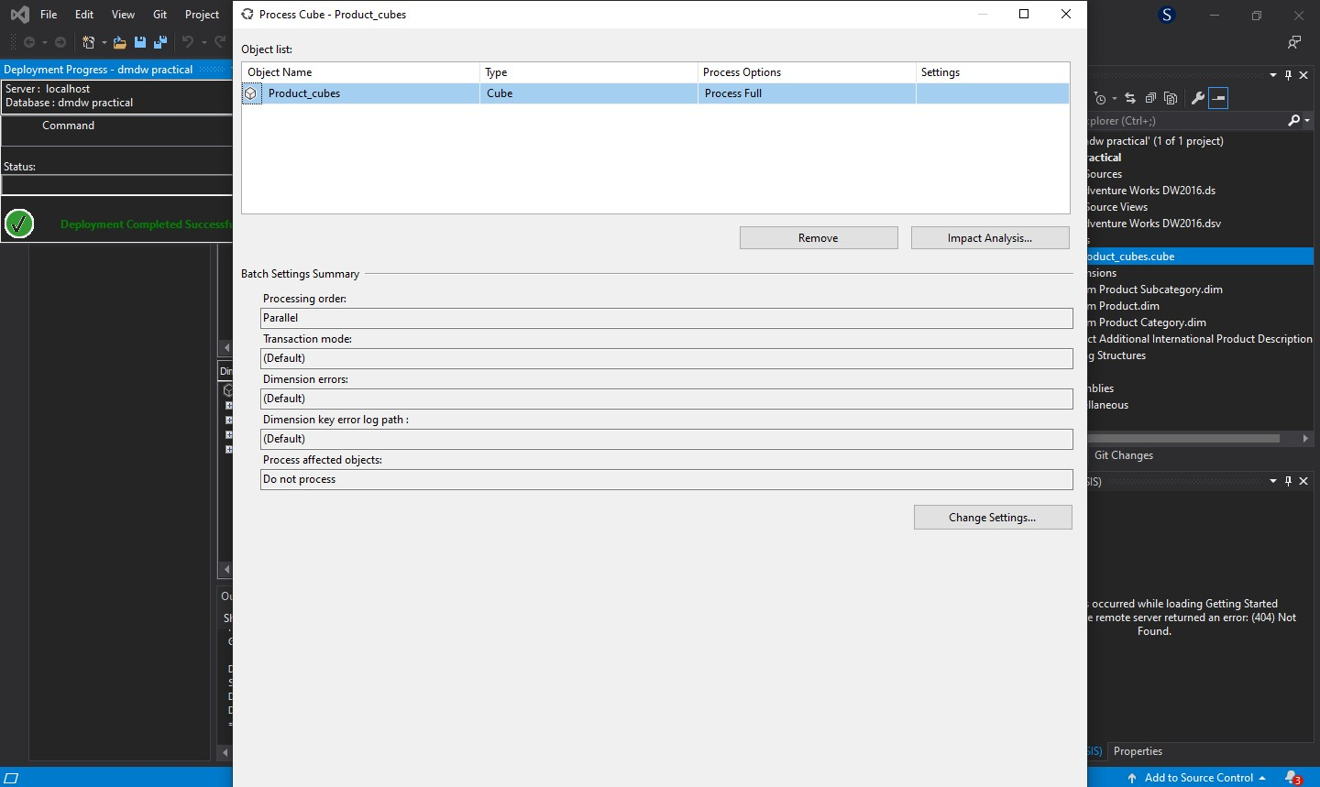

* Maximise this window to see the “Run” button.

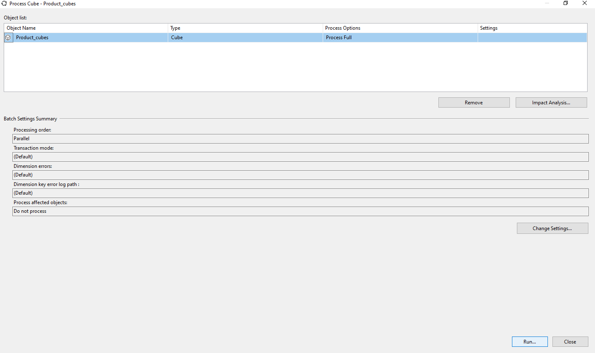

* Click the “Run” button to process the cube. If everything goes right, you should see the ‘Status’ as ‘Process succeeded’.

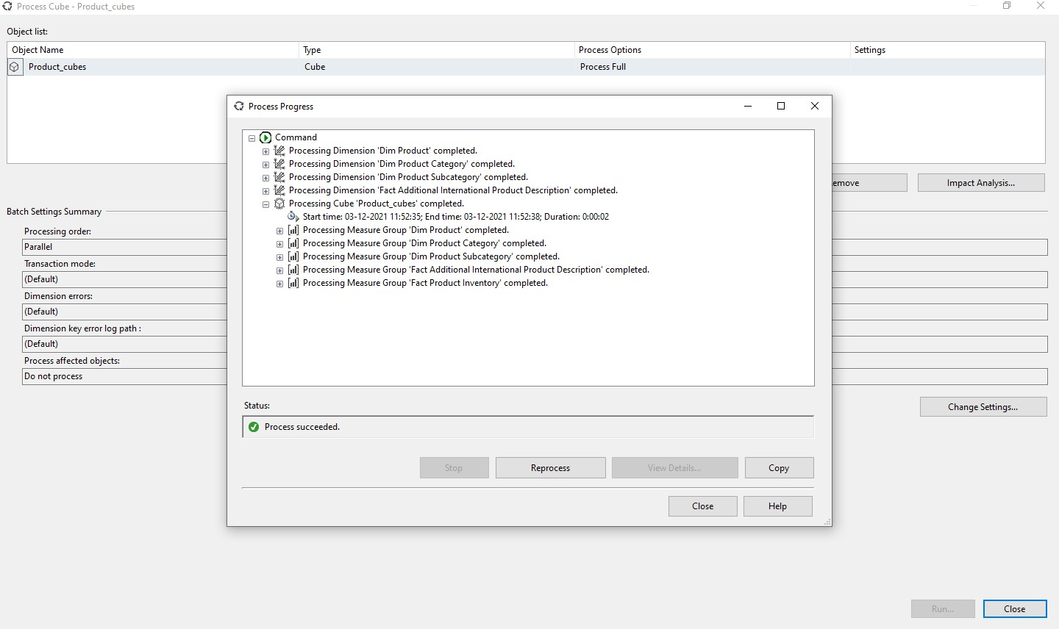

* Now, start Excel. Select the ‘Data’ section from the menu to display the Data ribbon. Select the “From Other Sources” button.

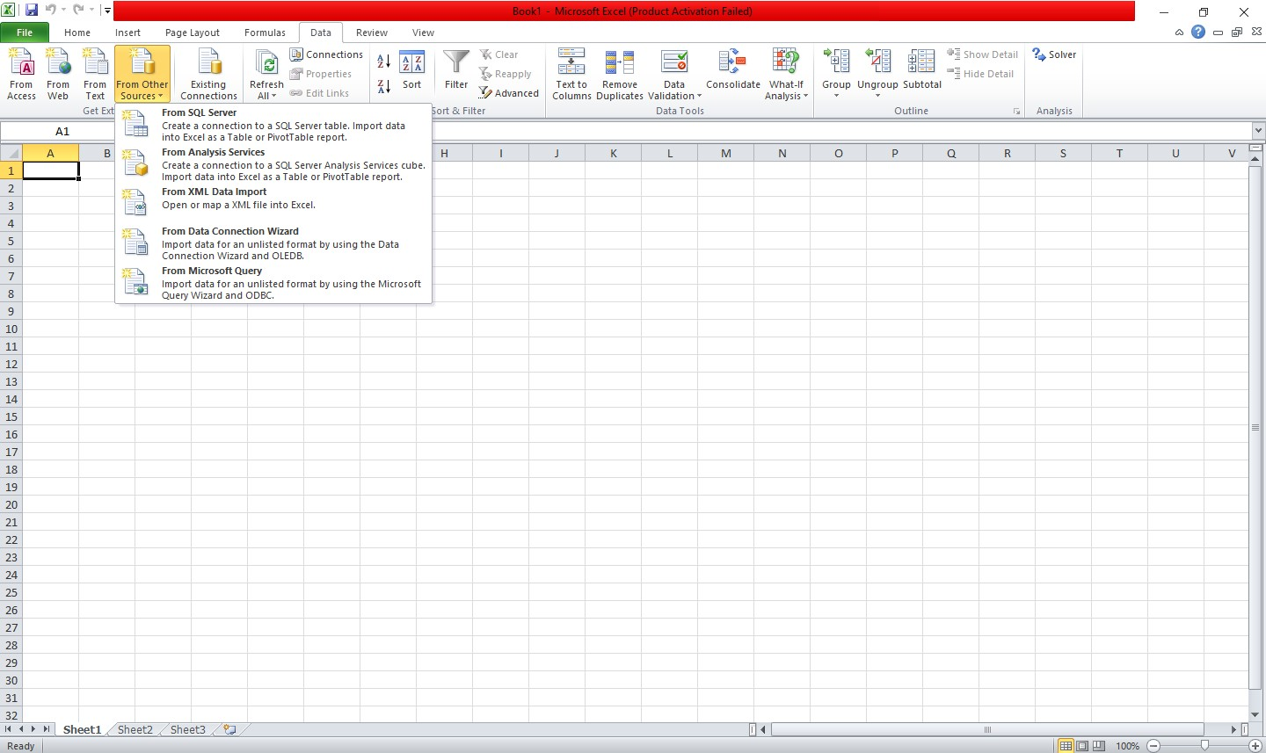

* This reveals a drop down list. Select the “From Analysis Service” option.

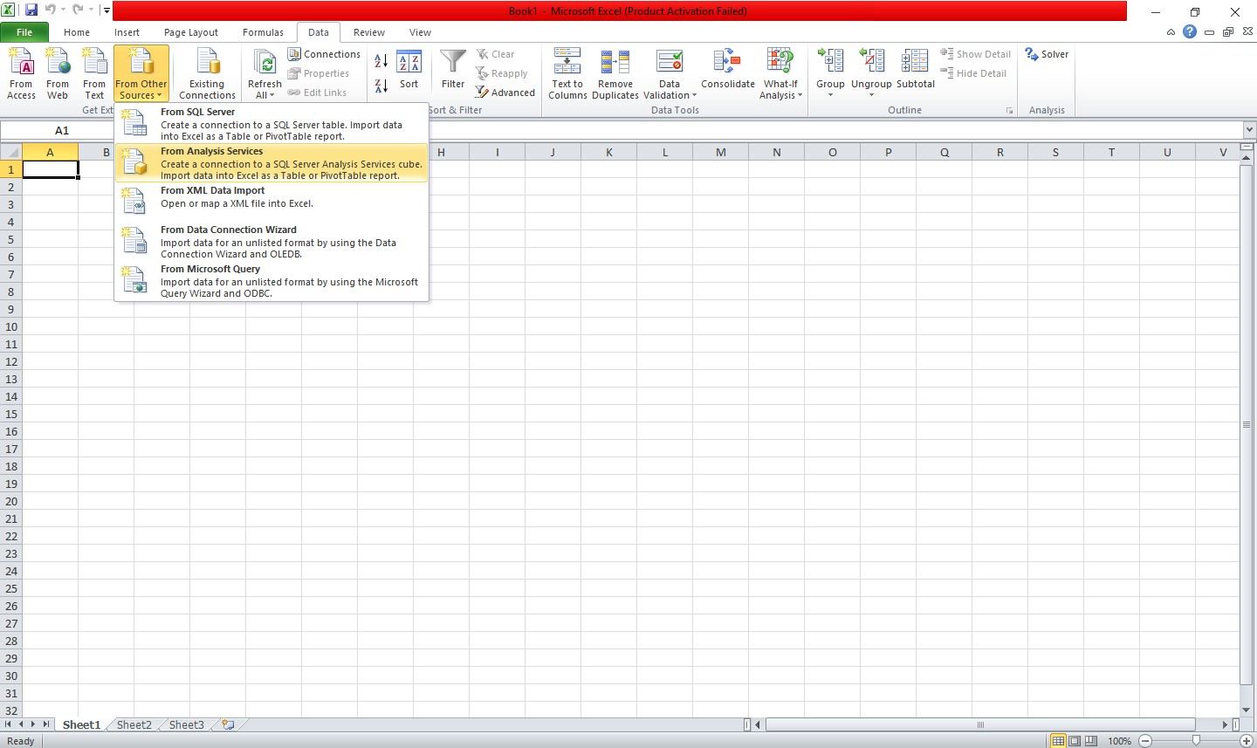

* Now, a popup window titled ‘Data Connection Wizard’ should appear. Enter ‘.’ or ‘localhost’ in the ‘Server Name’ text box.

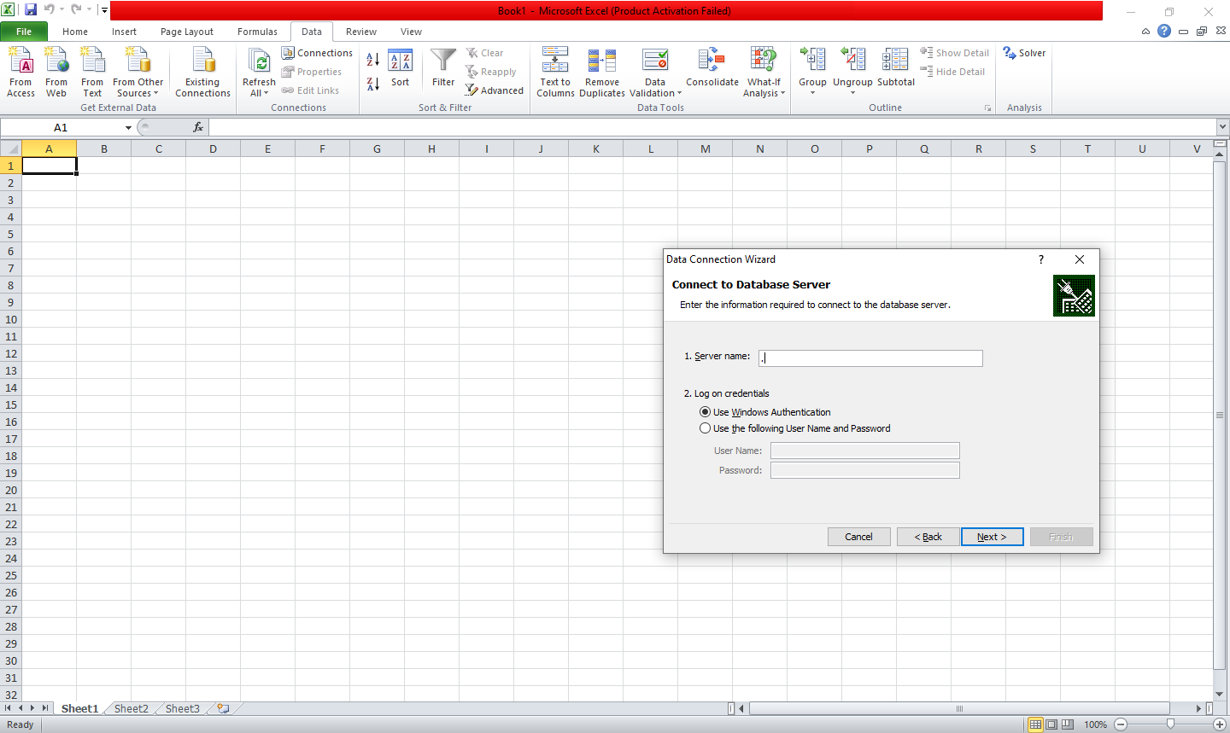

* Click on “Next”. The ‘Data Connection Wizard’ should now close and a new popup window called ‘Import Data’ should appear.

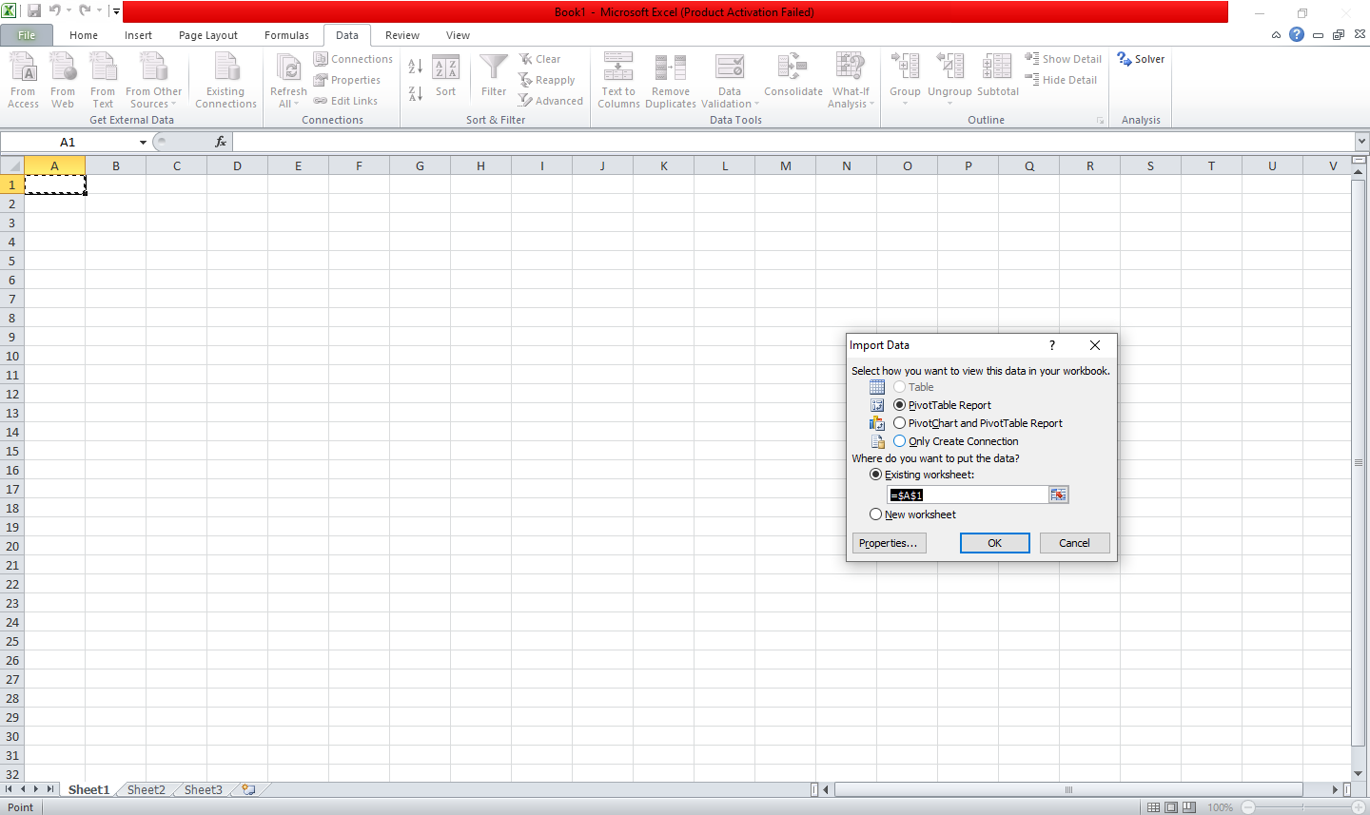

* Keep the default settings and click on “OK”. The current sheet should look like this:

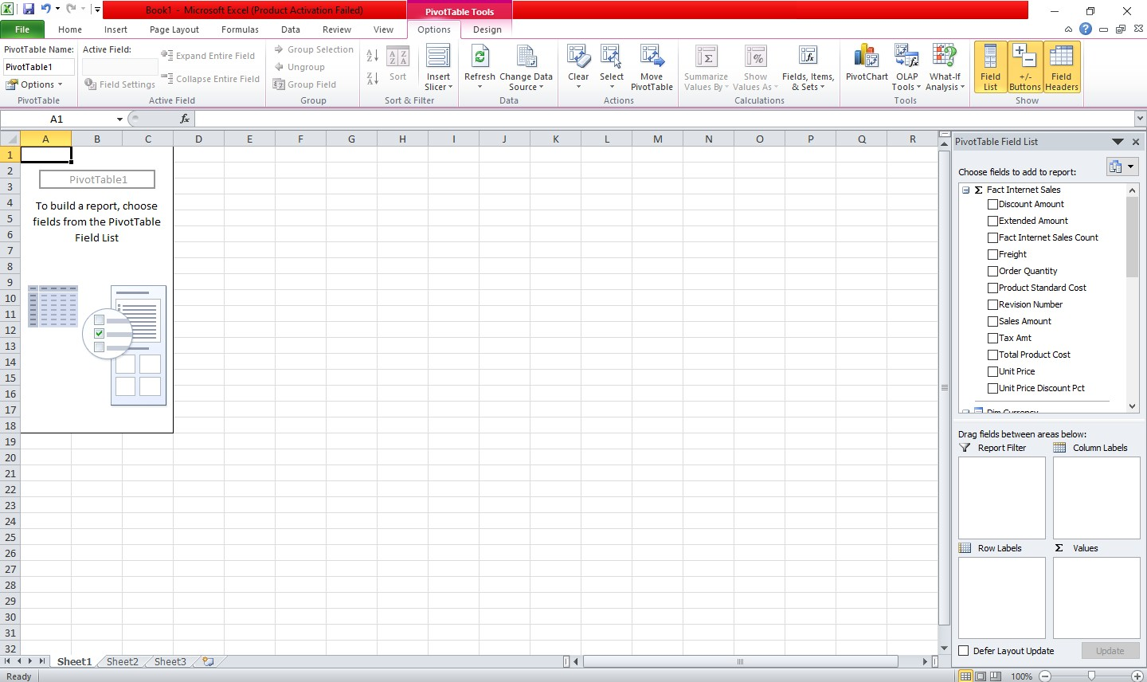

* Choose the items you want from the right pane. The spreadsheet will be updated automatically.

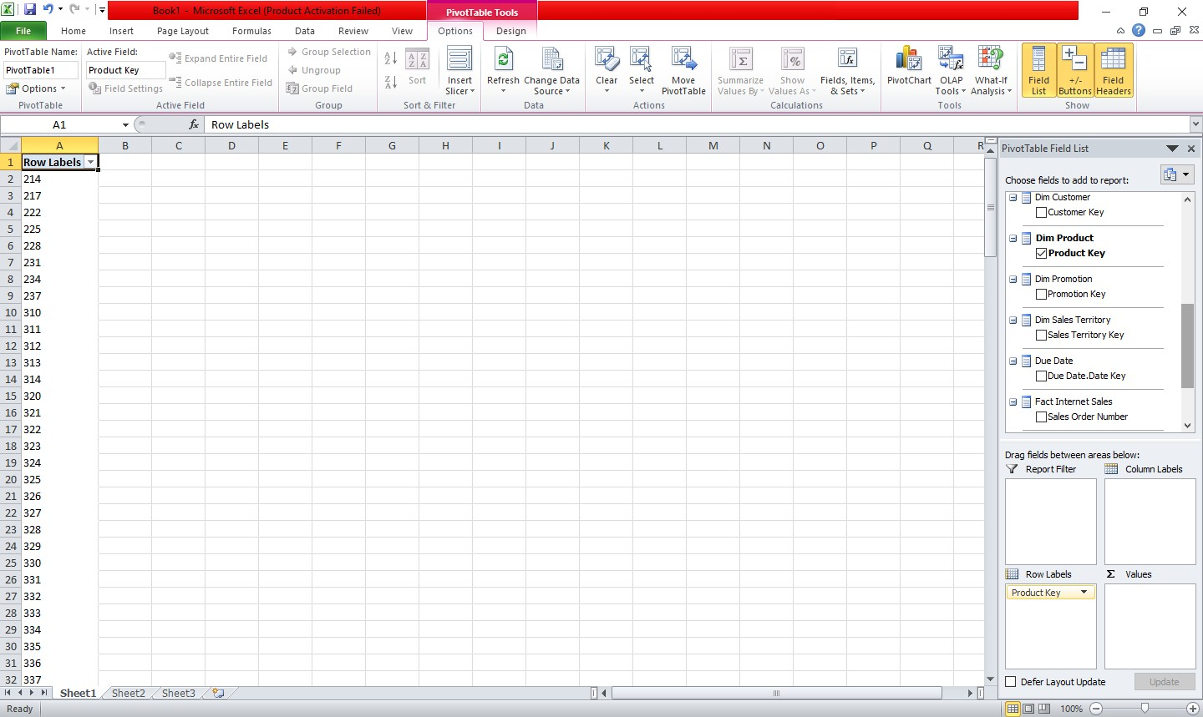

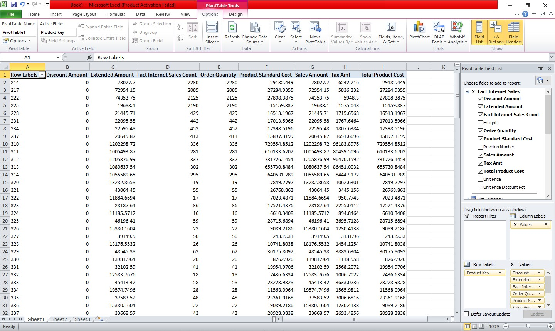

* Optionally, the data from the spreadsheet can also be plotted.





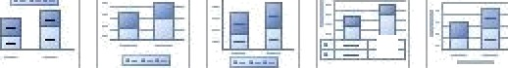Chain



ñhan ge S a .'e -.s

S it rh S el e ct

C hart T›'p e T e n pIat e R'a r. 'C's Iui»n D at a



E G H I J L

M .N

0 e ii‘.ctTable Fiel‹l List

*L* Customer Key Due Date Key Mended Amount Order Date Key Order Quantity Product Key Product Standard Cost Sales Amount Ship Date Key Tax Amt

|  |  |  |  |  |  |  |  |  |  |  |
| --- | --- | --- | --- | --- | --- | --- | --- | --- | --- | --- |
| 2 | 175270983 | 644369976 | 3649866.551 | 642037573 | 8993 | 3959260 | 2130235.255 | 3649966.551 | 642843860 2919B9.3303 | 2130235.255 |
| 3 | 432128 | 543524452 | d532.46B2 | 543523431 | 27 | 11d54 | 3629.7059 | 6532.4682 | 543524179 522.5975 | 3629.7059 |
| 4 | 3B786B | 402607696 | 3000.8296 | 402606410 | 20 | 9440 | 1649.9092 | 3000.8296 | 402607177 240.0664 | 1649.9092 |
| 5 | 240864748 | 2083291292 | 5718150.912 | 2C78858758 | 12265 | 5399266 | 3346387.415 | 5718150.812 | 2081293398 457452.C745 | 3346387.415 |

Total Product Cost

Sho'w' fields related to



Employee Key

Fact Sales Quota Count

|  |  |  |  |  |  |  |  |  |  |  |  |  |  |
| --- | --- | --- | --- | --- | --- | --- | --- | --- | --- | --- | --- | --- | --- |
| 6 | 703765 | 7B5120668 | 12238.B496 | 705101701 | 39 | 16559 | 6906.4234 | 2223B.B496 | 7B5120473 | 979.10B | 6906.4234 |  | Sales Amount Quota |
| 7 | 126724204 | -1221474518 | 2977B44.B62 | -1224004416 | 7620 | 3393715 | 1147923.361 | 1977B44.862 | -1222473563 | 15B227.5915 | 1147923.361 |  |  |
| 8 | 105581d45 | 214453172 | 2644017.714 | 212459560 | SSSB | 2414176 | 1557752.993 | 2644017.714 | 223304026 | 211521422 | 1557752.993 | -j | Dim Sales Reason |
| 9 | 10BB35347 | 1562B43581 | 2894312.339 | L560481563 | 5625 | 2424B91 | 1706941.573 | 2B94312.338 | 1562929058 | 231544.9914 | 1706941573 |  | Sales Reason Key |
| l0 | 250536372 | -1957717977 | 9061000.5B4 | -1962786BB5 | 13345 | 5811937 | 5375145.508 | 90610005B4 | -1960208540 | 7248B0.0666 | 5375145.508 | -j | Dim Sales Territory |
| Il | 128763056 | 15B0235609 | 3391712.211 | 1577675325 | 6906 | 29B6726 | 2001221433 | 3391722.211 | 1579204018 | 271336.9B19 | 2001221.433 |  | @S'aTes Territory key |
| 12 |  |  |  |  |  |  |  |  |  |  |  |  |  |
| 13 | 1138000116 | 342286655 | 2935867L22 | 3190BS724 | 60398 | 26427624 | 17277793.58 | 2935-8677.22 | 332276780 | 2J48694.23 | 17277793.5-8 | -j | Fact Internet Sales  @SaIes Order Number |

Sales Reaso. . . Dim Sales T Sales Territor . . . Cust Due . . . Extend. . . Order Order. . . Pro Product S. .. Sale. . . Ship . . . T. .. Total Pi . . .

15

16 8E+09

-j Fact Reseller Sales Sales Order Number



17

*'LR*

19

20

21

22

23

24

25

26

27

28

29

30

31



Ready i

6E+09

4E+09

2E+09





2E+09

4-E+09

6E+09

-8E+09

Sales Territory Key

5 7 iO 11



Values

*ota! Product Cost

*ax Amt

Ship Date Ke‘/ Sa .es Am ount

* Procluct Standard Cost

Pr 0 U K E'/

* Orr!e r Quant t/
* Orr!e r Date Key Extende d Amount

Drag fields bed 'een areas belo' ':

Report Filter Legend Fields . . .

Z Values

Axis Fields (Ca. . . Z Values

Sales Tei"iitor. . . Sales Rea. . . ^ Dim Sales . . .

Sales Teri . . . Customei . . . Due Date . . .

 

*”* Defer Layout Update



 